Python Assignment 4

Name – Archisman Roy Date – 06/11/2020

CSE 2nd year 3rd sem

Roll – 50

1. Write a program to check whether the string is palindrome or not.

2. Write a Python program to reverse words in a sentence.

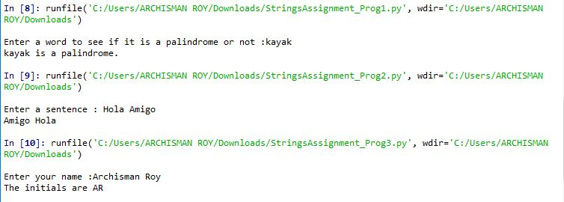3. Write a Python program which takes a name as input and print the initials.

Questionnaire

1. What are the advantages of using slice of strings?

Ans. The string slice in python is used to developed a new substring from the original string due to this there is effect is occurred in the original string it simply means the original string remains the same as it was it previous.

1. Can you directly replace a character in string just by assigning? If not, state the reason. Also give the solution.

Ans. The replace method doesn’t store the altered value in the same variable. So we can’t directly replace just by assigning.

We need to store it in another variable and print it.

1. What is the use of negative index?

Ans. The negative index is used to remove any new-line spaces from the string and allow the string to except the last character that is given as S[:-1]. The negative index is also used to show the index to represent the string in correct order.